**1.INTRODUCTION TO COMPANY**

**FORTUNE TECHNOLOGIES (NETWORK HUB)**

Fortune Technologies is a global IT Solutions company providing services in following fields :

• Network Administration

• Server Administration

• Software Development

• Android App Development

• Iphone App Development

• Web Development

• Search Engine Optimization

They have a team of highly educated, certified, highly experienced and talented professionals, every Teacher is expert in his own field. They provide quality and affordable solutions. They bring innovative ideas and the power of web and technology to our customers with which they can grow and promote their business in the best and fastest way.

Their main motive is to build long term relations with our clients and always provide them services in the best way possible. They are flexible and move with changing times and new technologies. Their Clients are everything for them, Clients are assured of best quality everytime.

**2. INTRODUCTION TO PROJECT**

**2.1 Overview:**

The system handles online restaurant management procedure. The project restaurant management system is a web based project that manages variety of all the activities related to the restaurant. This project provides time to time food item information availableat restaurant. The system reduces the time and cost and provides the facility to retrieve customers all information regarding the food. In today modern rush hour of the life, it is difficult for the foodies to go the restaurant every time they want to. But by this restaurant management system, it can be easier for a customer to get food delivered at home.

* + 1. **User Requirement Analysis**

Requirement Analysis is a preliminary study and evaluation of an activity such as a business to identify its desired objectives. It is the process used to elicit needs and resource constraints and to translate these into a viable operation.

In this section, we will look at two basic steps of Requirement Analysis of

**Property Boom**.

The two steps are:

* Identification of Need
* Preliminary Investigation

**Identification of Need**

The basis for development of any new system is recognition or identification of a need for improving an information system or procedure.

Every project begins with a Project Statement from customer, where he gives the basicidea of what he wants or how he sees what the problem is & what they believe where the solution lies? Second aspect is our(as IT executive or developer) thinking about the need of client & third aspect is the real problem which lies somewhere between first & second aspect.

Web Applications are programs that can be executed either on a web server for

Server side scripting or in a web browser for client side scripting. In addition, web

Applications can support online commercial transaction popularly known as e-commerce.

**Preliminary Investigation**

The need leads to a Preliminary Investigation or survey. The Preliminary Investigation or survey is used to determine whether an alternative system can solve the problem or not. It entails looking into the duplication of efforts, bottlenecks, inefficient existing procedures, or whether parts of existing system would be fit for computerization.

In seeking an appropriate solution to the problem, considerations that must be observed include

* Existing Application or System,
* Anticipated Changes in environment,
* Expected Lifetime of solution, and
* Time, cost, budget, benefit tradeoffs, and making boundaries

All this is called SCOPING OF PROJECT; and also includes:-

* Defining Project responsibilities.
* Dividing responsibilities individual tasks.
* Determining how much geographical area will be involved.
* Get estimated number of people who will use your application.
* Understanding how quickly client wants the application implemented.

**Planning**

The planning of any project depicts and conveys in which order from core to the final processing of the project is carried out. The final expected result shows that the project is successfully planned.

Software project managers take the overall responsibility of steering a project to success. This surely is a very hazy job description. But, it is very difficult to objectively describe the job responsibilities of a project manager.

Diving the whole project in modules and separately functioning on them finally results in the ease and successful implementation of the work to be carried out.

One of the major part is the study of feasibility study. The feasibility study consists of Technical , Economical , Behavioral.

**3.Feasibility Study**

It is a study of the solution of the problem that how much the solution solves the problem so as to check:

* What are the needs and how the problem can be solved?
* What resources are available?
* How well does it fit in the system?
* Feasibility study is important?

Feasibility study entails looking into details of various factors affecting the feasibility of the system. Feasibility study is the phase in which the analyst checks that therestaurant management system is feasible for the restaurant or not. This entails identification, description & evaluation of the system. Feasibility study is the phase in which the analyst checks that therestaurant management system is feasible for the restaurant or not. The feasibility study is one of the best systems that meet the performance requirements. If the feasibility study is to serve as a decision document these include.

There are aspects in the feasibility study portion of the preliminary investigation:

* Technical Feasibility
* Economical Feasibility
* Scheduled Feasibility

**Technical Feasibility:**Technical feasibility centers on the technology used. It means the restaurant management system is technically feasible. Our Project is technically feasible; it is providing us required output.

**Economical Feasibility:** This is commonly known as cost/benefit analysis. It is the procedure to determine the benefits and savings that are expected from a restaurant management system and compare them with cost.

**Scheduled Feasibility:** Behavioral feasibility is the analysis of behavior of the restaurant management system. In this we analyze the restaurant management system is working properly or not.

* 1. **Benefits of Project**

**Here are Reasons Why a Restaurant Management Software Is Important and Beneficial:**

Restaurant management styles vary depending on the type of establishment, but the one thing that restaurants have in common is that they exist to make a profit. [Restaurant management software](https://www.deputy.com/blog/5-benefits-of-investing-in-restaurant-technology) helps managers maximize profits, reduce costs, and provide an exceptional customer experience. Suitable restaurant management software provides the benefits of increased efficiencies and reduced mismanagement.

## 3.1.1Attendance Management

Tracking employee performance and attendance is a painstakingly difficult task if you were to do it manually. Thankfully, with an RMS, you have an added benefit of managing time and attendance for your waiters, managers, chefs, cooks and restaurant employees. The age-old method of using Excel spreadsheets, printed contracts, and paper sheets is weeding away with the passage of time. Restaurant and cafe owners have become smarter than they were before, and with a little investment, they can now do all that is required to maintain operational effectiveness and efficiency. Restaurant owners know that having a well-managed system in place reduces their time, costs and efforts in managing the workforce.

Here are some of the features of a typical restaurant management software with workforce management capabilities:

* Update employee availability
* Employee time attendance
* Employee leave and absent reports
* Employee scheduling

## 3.1.2 Inventory Control

The success of your restaurant or cafe will depend upon how successfully you purchase, store, manage and efficiently use your inventory by analyzing the demand from customers and supply from suppliers.

Inventory is also one of the biggest direct expenses of a restaurant, and one that needs to be consistently kept tabs on.

Know in real-time about your inventory, such as how much has been purchased, used, wasted, in stock, in kitchen, etc. The benefit is to save food from getting wasted, and streamline your inventory management process to understand and serve customer demands in a better manner.

Remember, wastage is a huge cost for any business. Save food, save money and increase profits. This is and should be the aim of a high-end restaurant management software.

## 3.1.3 Tracking Sales

Sales is a challenging aspect to track and maintain. From customers spending in cash and credit cards to account for expenses, taxes, and profits, you need a restaurant management software that does it all for you.

With our restaurant management software, you get the added advantage of a tablet ordering system and a POS management system. Everything will be streamlined. When waiters take orders, they do it on the tablet, which is in real-time integrated with the backend to track expenses, revenue, and sales. You can generate weekly or monthly reports in order to know sales revenue from each item in the menu, cash sales, or card sales and much much more.

## 3.1.4 Credit and Debit Card Processing

While cash still dominates the Asian marketplace when it comes to making transactions, there has been an increasing use of credit cards among customers. It is therefore important, to cater to all types of customer that will impact the bottom line, i.e. sales revenue. Your restaurant management software should be able to take care of credit/debit card and cash sales.

## 3.1.5 Preparation of Financial Statements

What’s good about a restaurant management software that does not provide financial statements? You should be able to generate weekly and monthly reports of financial statements that track down your expenses, revenue, taxes, salaries, inventory and much more.Restaurant management software simplifies the process of financial statement preparation, such as profit and loss statements, tax statements, and so on. With such a feature, all the necessary figures can be accessed instantly through the system, and this as expected will save lots of time and effort.

Our RMS does that for you and so should any ideal RMS do.

## 3.1.6Cloud access

With our software, you get cloud access to the system whereby everything is done and stored in the cloud. You don’t have to worry about safety, server accessability, and security of your data.

**4.Project Design**

**4.1 Project perspective**

This subsection of the SRS relates the modules to other modules or projects.

(1)  Our project is independent and totally self-contained, it should be stated here.

(2)  The SRS defines a project that is a component of a larger system or project:

(a)  Describe the functions of each component of the larger system or project, and identify interfaces.

(b)  Identify the principal external interfaces of this software product (not a detailed description)

(c)  Describe the computer hardware and peripheral equipment to be used (overview only)

Our project is an PHP website. It helps to keep the record and maintain the record of properties.

**4.2 User Characteristics**

Describe those general characteristics of the eventual users of the project that will affect the specific requirements.

Many people interact with a system during the operation and maintenance phase of the software life cycle. Some of these people are users, operators, and maintenance and systems personnel. Certain characteristics of these people, such as educational level, experience, and technical expertise impose important constraints on the system's operating environment.

**4.3 Use case model/DFDS**

The Use Case Model describes the proposed functionality of the Management system.



**Figure 4.3.1 Use Case Model for RESTAURANT MANAGEMENT SYSTEM**

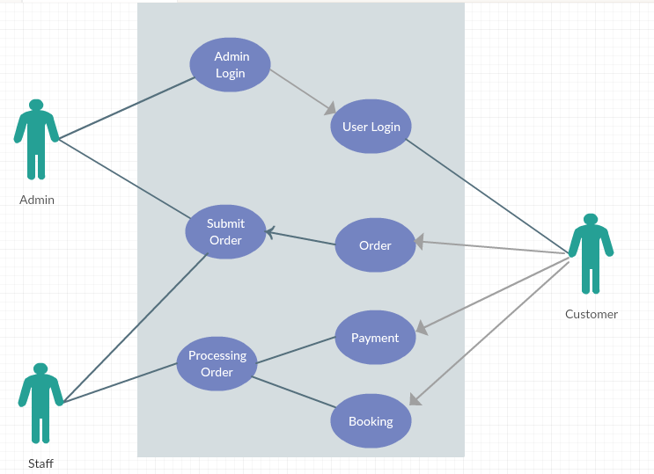

**Figure 4.3.2 Use Case Model forFutureRESTAURANT MANAGEMENT SYSTEM**

**4.4 DFDS (Data Flow Diagrams)**

A **data-flow diagram** (**DFD**) is a graphical representation of the "flow" of data through an information system. DFDs can also be used for the visualization of data processing (structured design).

DFDs represent the following:

1. External devices sending and receiving data

2. Processes that change that data

3. Data flows themselves

4. Data storage locations

**4.4.1 INTRODUCTION OF DFD:-**

A DFD, in simple words, is a hierarchical graphical model of a system that shows the different processing activities or functions that the system performs and the data interchange among these functions. In the DFD terminology, it is useful to consider each function as a process that consumes some input data and produces some output data.

The DFD (also known as the bubble chart) is a simple graphical formalism that can be used to represent a system in terms of the input data to the system, various processing carried out on these data, and the output data generated by the system) The main reason why the DFD technique is so popular is probably because of the fact that DFD is a very simple formalism- it is simple to understand and use. A DFD model uses a very limited number of primitive symbols to represent the functions performed by a system and the data flow among these functions. Starting with a set of high-level functions that a system performs, a DFD model hierarchically represents various sub functions. In fact, any hierarchical model is simple to understand. Human mind is such that it can easily understand any hierarchical model of a system-because in a hierarchical model, starting with a very simple and abstract model of a system; different details of the system can be slowly introduced through different hierarchies.

**4.4.2 NEED OF DFD**

DFD aim’s to capture the transformation that takes place within a system to the input data so that eventually output is produced. It makes easier for user to understand the flow of data.

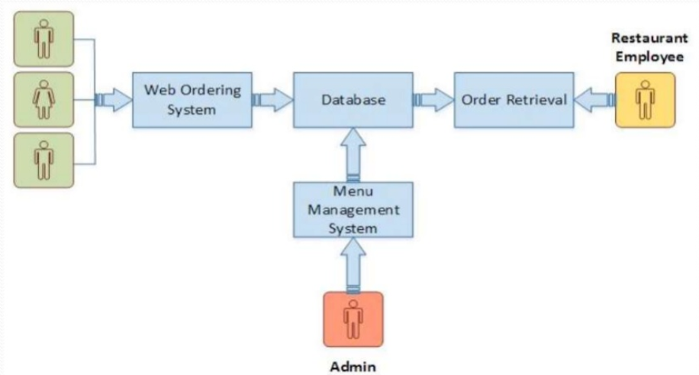

**Figure 4.4.1 Data Flow Diagram**

**5. Data Base Design**

A database is an organized mechanism that has the capability of storing information through which a user can retrieve stored information in an effective and efficient manner. The data is the purpose of any database and must be protected.

The database design is a two level process. In the first step, user requirements are gathered together and a database is designed which will meet these requirements as clearly as possible. This step is called Information Level Design and it is taken independent of any individual DBMS.

In the second step, this Information level design is transferred into a design for the specific DBMS that will be used to implement the system in question. This step is called Physical Level Design, concerned with the characteristics of the specific DBMS that will be used. A database design runs parallel with the system design.

The organization of the data in the database is aimed to achieve the following two major objectives.

* Data Integrity
* Data independence

Normalization is the process of decomposing the attributes in an application, which results in a set of tables with very simple structure. The purpose of normalization is to make tables as simple as possible.

Normalization is carried out in this system for the following reasons.

* To structure the data so that there is no repetition of data, this helps in saving.
* To permit simple retrieval of data in response to query and report request.
* To simplify the maintenance of the data through updates, insertions,
* Deletions.
* To reduce the need to restructure or reorganize data which new application
* Requirements arise.

**5.1Tables used in database**

Table-

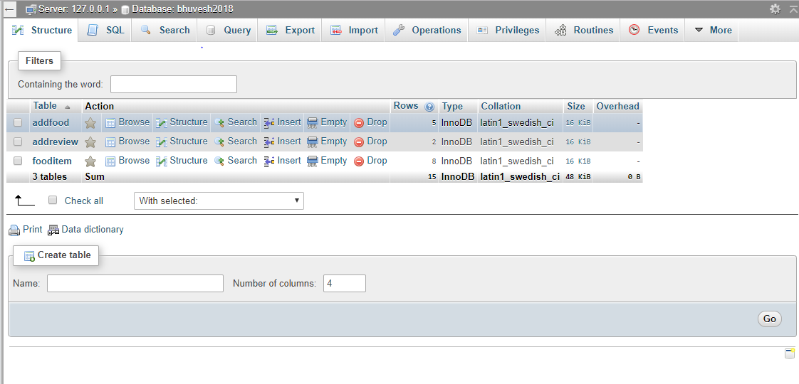

**Table-5.2 Table Structure**

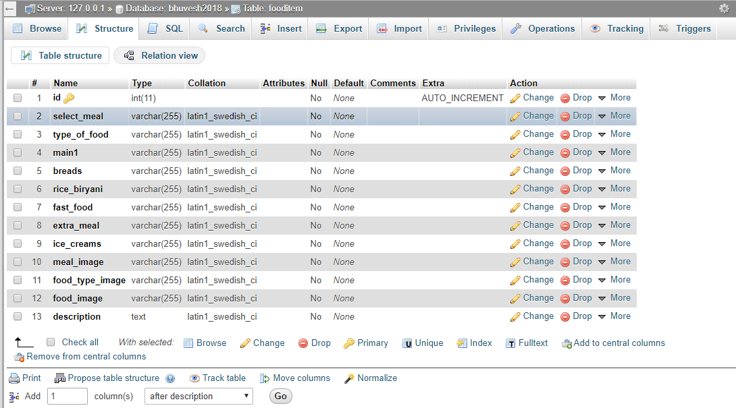

**6. ER Diagrams**

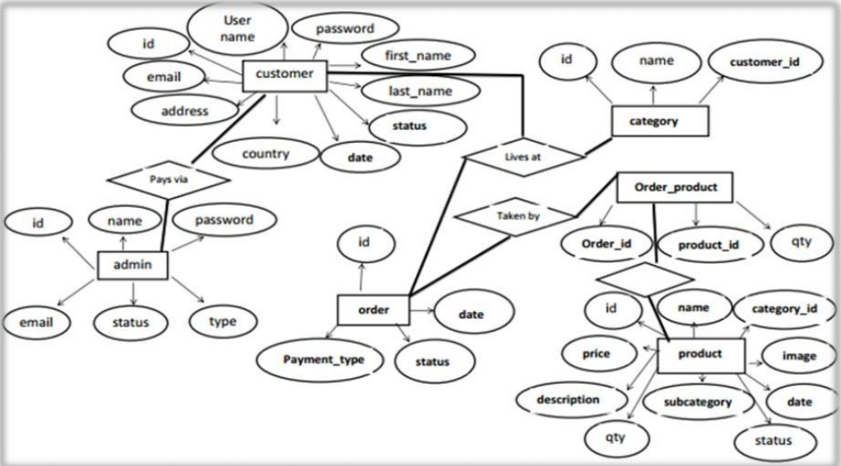

**Fig- ER diagram**

**6.1Assumptions and Dependencies**

A number of factors that may affect the requirements include:

* Any user should be a register user before admission.
* Admin can delete the any module or user if user violates the law.
* We assumed that the minimum age of user is 18 years.

It includes the following dependencies:

* Time dependency
* Hardware dependency
* External dependency

**Time dependency:**

If the admin thinks that the concerned property is not of interest then admin can delete the property after one month.

**Database Dependency:**

This project is of no use without database.

**7. Specific Requirements**

A **requirement** is a singular documented need of what a particular product or service should be or perform. It is most commonly used in a formal sense in systems engineering or software engineering.

This section of the SRS should contain all the details the software developer needs to create a design.  This is typically the largest and most important part of the SRS. Software Requirement Specification (SRS) is the starting point of the software development activity. It is a complete description of the behavior of a system which is to be developed. The SRS document enlists all necessary requirements for project development.

A SRS is a comprehensive description of the intended purpose and environment for software under development. The SRS fully describes what the software will do and how it will be expected to perform. An SRS minimizes the time and effort required by developers to achieve desired goals and also minimizes the development cost. A good SRS defines how an application will interact with system hardware, other programs and human users in a wide variety of real-world situations.

**7.1Requirements are of two types:**

Functional Requirement: In systems engineering, a requirement can be a description of what a system must do, referred to as a Functional Requirement. This type of requirement specifies something that the delivered system must be able to do.

**Non-functional requirement:**Another type of requirement specifies something about the system itself, and how well it performs its functions. Such requirements are often called Non-functional requirements, or 'performance requirements' or 'quality of service requirements.' Examples of such requirements include usability, availability, reliability, supportability, testability, maintainability, and ease-of-use.

**7.2Characteristics of SRS:**

•**Correct -** An SRS is correct if, and only if, every requirement stated therein is one that the software shall meet. Traceability makes this procedure easier and less prone to error.

•**Unambiguous -** An SRS is unambiguous if, and only if, every requirement stated therein has only one interpretation. As a minimum, this requires that each characteristic of the final product be described using a single unique term.

• **Verifiable –** It is verifiable if there exists some finite cost-effective process with which a person or machine check whether software product meets requirements.

• **Consistent -** Consistency refers to internal consistency. If an SRS does not agree with some higher-level document, such as a system requirements specification, then it is not correct. An SRS is internally consistent if, and only if, no subset of individual requirements described in it conflict.

• **Modifiable –** SRS is said to be modifiable if its structure and style are such that any changes to the requirements can be made easily, completely and consistently while retaining the structure and style.

**7.3System Requirements**

**Hardware Requirements:**

|  |  |
| --- | --- |
| **Processor:** | 1.70 GHz Dual core processor |
| **Ram:** | 4GB Ram and above |
| **Hard Disk:** | 300 MB typical, 360 MB maximum. |
| **PHP Version :** | 7.2 | |

**Software Requirements:**

|  |  |
| --- | --- |
| **Platform:** | Windows operating system |
| **Front End…….. Development:** | PHP,HTML,CSS |
| **Back End ……...Database:** | MYSQL |
| **Editor :** | Dreamweaver |

**8. Development and Implementation**

* 1. **Introduction to Languages (Front End and Back End)**

**8.1.1 Front End:PHP**

**Introduction to PHP**



**PHP** is a [scripting language](http://en.wikipedia.org/wiki/Scripting_language) originally designed for producing [dynamic web pages](http://en.wikipedia.org/wiki/Dynamic_web_page). It has evolved to include a [command line interface](http://en.wikipedia.org/wiki/Command_line_interface) capability and can be used in [standalone](http://en.wikipedia.org/wiki/Standalone_software)[graphical applications](http://en.wikipedia.org/wiki/Graphical_user_interface).

While PHP was originally created by [Rasmus Lerdorf](http://en.wikipedia.org/wiki/Rasmus_Lerdorf) in 1995, the main implementation of PHP is now produced by **The PHP Group** and serves as the [de facto standard](http://en.wikipedia.org/wiki/De_facto_standard) for PHP as there is no [formal specification](http://en.wikipedia.org/wiki/Formal_specification). PHP is [free software](http://en.wikipedia.org/wiki/Free_software) released under the [PHP License](http://en.wikipedia.org/wiki/PHP_License), however it is incompatible with the [GNU General Public License](http://en.wikipedia.org/wiki/GNU_General_Public_License) (GPL), due to restrictions on the usage of the term PHP.

PHP is a widely-used general-purpose scripting language that is especially suited for [web development](http://en.wikipedia.org/wiki/Web_development)and can be embedded into [HTML](http://en.wikipedia.org/wiki/HTML). It generally runs on a [web server](http://en.wikipedia.org/wiki/Web_server), taking PHP code as its input and creating [web pages](http://en.wikipedia.org/wiki/Web_page) as output. It can be deployed on most web servers and on almost every [operating system](http://en.wikipedia.org/wiki/Operating_system) and [platform](http://en.wikipedia.org/wiki/Platform_%28computing%29) free of charge. PHP is installed on more than 20 million websites and 1 million [web servers](http://en.wikipedia.org/wiki/Web_server).

PHP is the Web development language written by and for Web developers.PHP stands for PHP: Hypertext Preprocessor. The product was originally named Personal Home Page Tools, and many people still think that’s what the acronym stands for. But as it expanded in scope, a new and more appropriate (albeit GNU-ishly recursive) name was selected by community vote. PHP is currently in its fifth major rewrite, called PHP5 or just plain PHP. PHP is a server-side scripting language, which can be embedded in HTML or used as a standalone binary (although the former use is much more common). Proprietary products in this niche are Microsoft’s Active Server Pages, Macromedia’s ColdFusion, and Sun’s Java Server Pages. Some tech journalists used to call PHP “the open source ASP” because its functionality is similar to that of the Microsoft product—although this formulation was misleading, as PHP was developed before ASP. Over the past few years, however, PHP and server-side Java have gained momentum, while ASP has lost mindshare, so this comparison no longer seems appropriate. We’ll explore server-side scripting more thoroughly in Chapter 2, but for the moment you can think of it as a collection of super-HTML tags or small programs that run inside your Web pages—except on the server side, before they get sent to the browser. For example, you can use PHP to add common headers and footers to all the pages on a site or to store form-submitted data in a database. Strictly speaking, PHP has little to do with layout, events, on the fly DOM manipulation, or really anything about what a Web page looks and sounds like. In fact, most of what PHP does is invisible to the end user. Someone looking at a PHP page will not necessarily be able to tell that it was not written purely in HTML, because usually the result of PHP is HTML. PHP is an official module of Apache HTTP Server, the market-leading free Web server that runs about 67 percent of the World Wide Web (according to the widely quoted Netcraft Web server survey). This means that the PHP scripting engine can be built into the Web server itself, leading to faster processing, more efficient memory allocation, and greatly simplified maintenance. Like Apache Server, PHP is fully cross-platform, meaning it runs native on several flavors of Unix, as well as on Windows and now on Mac OS X. All projects under the aegis of the Apache Software Foundation—including PHP—are open source software..

## Usage

PHP is a general-purpose scripting language that is especially suited for [web development](http://en.wikipedia.org/wiki/Web_development). PHP generally runs on a [web server](http://en.wikipedia.org/wiki/Web_server), taking PHP code as its input and creating [web pages](http://en.wikipedia.org/wiki/Web_page) as output. It can also be used for [command-line](http://en.wikipedia.org/wiki/Command-line) scripting and [client-side](http://en.wikipedia.org/wiki/Client-side)[GUI](http://en.wikipedia.org/wiki/Graphical_user_interface) applications. PHP can be deployed on most [web servers](http://en.wikipedia.org/wiki/Web_server), many [operating systems](http://en.wikipedia.org/wiki/Operating_system) and [platforms](http://en.wikipedia.org/wiki/Platform_%28computing%29), and can be used with many [relational database management systems](http://en.wikipedia.org/wiki/Relational_database_management_system). It is available free of charge, and the PHP Group provides the complete source code for users to build, customize and extend for their own use.

PHP primarily acts as a [filter](http://en.wikipedia.org/wiki/Filter_%28software%29), taking input from a file or stream containing text and/or PHP instructions and outputs another stream of data; most commonly the output will be HTML.

Originally designed to create dynamic web pages, PHP's principal focus is [server-side scripting](http://en.wikipedia.org/wiki/Server-side_scripting), and it is similar to other server-side scripting languages that provide dynamic content from a web server to a [client](http://en.wikipedia.org/wiki/Client_%28computing%29), such as [Microsoft](http://en.wikipedia.org/wiki/Microsoft)'s [Active Server Pages](http://en.wikipedia.org/wiki/Active_Server_Pages), [Sun Microsystems](http://en.wikipedia.org/wiki/Sun_Microsystems)' [Java Server Pages](http://en.wikipedia.org/wiki/JavaServer_Pages), and [mod_perl](http://en.wikipedia.org/wiki/Mod_perl). PHP has also attracted the development of many [frameworks](http://en.wikipedia.org/wiki/Software_framework) that provide building blocks and a design structure to promote [rapid application development](http://en.wikipedia.org/wiki/Rapid_application_development) (RAD). Some of these include [CakePHP](http://en.wikipedia.org/wiki/CakePHP), [Symfony](http://en.wikipedia.org/wiki/Symfony), [CodeIgniter](http://en.wikipedia.org/wiki/CodeIgniter), and [Zend Framework](http://en.wikipedia.org/wiki/Zend_Framework), offering features similar to other [web application frameworks](http://en.wikipedia.org/wiki/List_of_web_application_frameworks).The [LAMP](http://en.wikipedia.org/wiki/LAMP_%28software_bundle%29) architecture has become popular in the web industry as a way of deploying web applications. PHP is commonly used as the P in this bundle alongside [Linux](http://en.wikipedia.org/wiki/Linux), [Apache](http://en.wikipedia.org/wiki/Apache_HTTP_Server) and [MySQL](http://en.wikipedia.org/wiki/MySQL), although the P may also refer to [Python](http://en.wikipedia.org/wiki/Python_%28programming_language%29) or [Perl](http://en.wikipedia.org/wiki/Perl).

As of April 2007, over 20 million Internet domains were hosted on servers with PHP installed, and PHP was recorded as the most popular Apache module. Significant websites are written in PHP including the user-facing portion of [Facebook](http://en.wikipedia.org/wiki/Facebook), [Wikipedia](http://en.wikipedia.org/wiki/Wikipedia) ([MediaWiki](http://en.wikipedia.org/wiki/MediaWiki)), [Yahoo!](http://en.wikipedia.org/wiki/Yahoo%21), [My Yearbook](http://en.wikipedia.org/wiki/MyYearbook), [Digg](http://en.wikipedia.org/wiki/Digg), [Word Press](http://en.wikipedia.org/wiki/WordPress) and [Tagged](http://en.wikipedia.org/wiki/Tagged).

In addition to server-side scripting, PHP can be used to create stand-alone, compiled applications and libraries, it can be used for shell scripting, and the PHP binaries can be called from the command line.

BACK-END USED

**9. MySQL**

MySQL, the most popular Open Source SQL(structured query language) database management system, is developed, distributed, and supported by Sun Microsystems, Inc.

The MySQL Web site provides the latest information about MySQL software.

* MySQL is a database management system.

A database is a structured collection of data. It may be anything from a simple shopping list to a picture gallery or the vast amounts of information in a corporate network. To add, access, and process data stored in a computer database, you need a database management system such as MySQL Server. Since computers are very good at handling large amounts of data, database management systems play a central role in computing, as standalone utilities, or as parts of other applications.

* MySQL is a relational database management system.

A relational database stores data in separate tables rather than putting all the data in one big storeroom. This adds speed and flexibility. The SQL part of “MySQL” stands for “Structured Query Language.” SQL is the most common standardized language used to access databases and is defined by the ANSI/ISO SQL Standard. The SQL standard has been evolving since 1986 and several versions exist.

* MySQL software is Open Source.

Open Source means that it is possible for anyone to use and modify the software. Anybody can download the MySQL software from the Internet and use it without paying anything. If you wish, you may study the source code and change it to suit your needs.

* The MySQL Database Server is very fast, reliable, and easy to use.

If that is what you are looking for, you should give it a try. MySQL Server also has a practical set of features developed in close cooperation with our users. You can find a performance comparison of MySQL Server with other database managers on our benchmark page.

MySQL Server was originally developed to handle large databases much faster than existing solutions and has been successfully used in highly demanding production environments for several years. Although under constant development, MySQL Server today offers a rich and useful set of functions. Its connectivity, speed, and security make MySQL Server highly suited for accessing databases on the Internet.

The MySQL Database Software is a client/server system that consists of a multi-threaded SQL server that supports different backends, several different client programs and libraries, administrative tools, and a wide range of application programming interfaces (APIs).

We also provide MySQL Server as an embedded multi-threaded library that you can link into your application to get a smaller, faster, easier-to-manage standalone product.

* A large amount of contributed MySQL software is available.

It is very likely that your favourite application or language supports the MySQL Database Server.

**10. Any other supporting languages**

**10.1 HTML**

HTML is a language for describing web pages.

* HTML stands for **H**yper **T**ext **M**arkup **L**anguage
* HTML is not a programming language, it is a **markup language**
* A markup language is a set of **markup tags**
* HTML uses **markup tags** to describe web pages

## HTML Tags

HTML markup tags are usually called HTML tags

* HTML tags are keywords surrounded by angle brackets like <html>
* HTML tags normally come in pairs like <b> and </b>
* The first tag in a pair is the start tag, the second tag is the end tag
* Start and end tags are also called opening tags and closing tags.

## HTML Documents = Web Pages

* HTML documents describe web pages
* HTML documents contain HTML tags and plain text

The purpose of a web browser (like Internet Explorer or Firefox) is to read HTML documents and display them as web pages. The browser does not display the HTML tags, but uses the tags to interpret the content of the page

## <html> <body> <h1>My First Heading</h1> <p>My first paragraph</p> </body> </html>

## Editing HTML

In this tutorial we use a plain text editor (like Notepad) to edit HTML. We believe this is the best way to learn HTML.

## HTML Headings

HTML headings are defined with the <h1> to <h6> tags.

<h1>This is a heading</h1>

## HTML Paragraphs

HTML paragraphs are defined with the <p> tag.

<p>This is a paragraph</p>

## HTML Links

HTML links are defined with the <a> tag.

<a href="http://www.w3schools.com">This is a link</a>

## HTML Images

HTML images are defined with the <img> tag.

<img src="w3schools.jpg" width="104" height="142" />

## HTML Element Syntax

* An HTML element starts with a **start tag / opening tag**
* An HTML element ends with an **end tag / closing tag**
* The **element content** is everything between the start and the end tag
* Some HTML elements have **empty content**
* Empty elements are **closed in the start tag**
* Most HTML elements can have **attributes**

## Text Formatting Tags

|  |  |
| --- | --- |
| **Tag** | **Description** |
| <b> | Defines bold text |
| <big> | Defines big text |
| <em> | Defines emphasized text |
| <i> | Defines italic text |
| <small> | Defines small text |
| <strong> | Defines strong text |
| <sub> | Defines subscripted text |
| <sup> | Defines superscripted text |
| <ins> | Defines inserted text |
| <del> | Defines deleted text |
| <s> | Deprecated. Use <del> instead |
| <strike> | Deprecated. Use <del> instead |
| <u> | Deprecated. Use styles instead |

For all the above: Use styles instead.

## Forms

A form is an area that can contain form elements.

Form elements are elements that allow the user to enter information (like text fields, textarea fields, drop-down menus, radio buttons, checkboxes, etc.) in a form.

A form is defined with the <form> tag.

## Input:

The most used form tag is the <input> tag. The type of input is specified with the type attribute. The most commonly used input types are explained below.

### Text Fields

Text fields are used when you want the user to type letters, numbers, etc. in a form.

<form>

First name:

<input type="text" name="firstname" />

<br />

Last name:

<input type="text" name="lastname" />

</form>

How it looks in a browser:

Top of Form

First name:

Last name :

**Bottom of Form**

**Note:** that the form itself is not visible. Also note that in most browsers, the width of the text field is 20 characters by default.

### Radio Buttons

Radio Buttons are used when you want the user to select one of a limited number of choices.

<form>

<input type="radio" name="sex" value="male" /> Male

<br />

<input type="radio" name="sex" value="female" /> Female

</form>

How it looks in a browser:

Male

Female

Bottom of Form

Note: that only one option can be chosen.

### Checkboxes

Checkboxes are used when you want the user to select one or more options of a limited number of choices.

<form>

I have a bike:

<input type="checkbox" name="vehicle" value="Bike" />

How it looks in a browser:

Top of Form

I have a bike:

Bottom of Form

## The Form's Action Attribute and the Submit Button

When the user clicks on the "Submit" button, the content of the form is sent to the server. The form's action attribute defines the name of the file to send the content to. The file defined in the action attribute usually does something with the received input.

<form name="input" action="html_form_submit.asp" method="get">

Username:

<input type="text" name="user" />

<input type="submit" value="Submit" />

</form>

How it looks in a browser:

Top of Form

Username:

C:\Users\DELL\Pictures\projct web\submit.jpg

Bottom of Form

If you type some characters in the text field above, and click the "Submit" button, the browser will send your input to a page called "html_form_submit.asp". The page will show you the received input.

## Form Tags

|  |  |
| --- | --- |
| **Tag** | **Description** |
| <form> | Defines a form for user input |
| <input> | Defines an input field |
| <textarea> | Defines a text-area (a multi-line text input control) |
| <label> | Defines a label to a control |
| <fieldset> | Defines a fieldset |
| <legend> | Defines a caption for a fieldset |
| <select> | Defines a selectable list (a drop-down box) |
| <optgroup> | Defines an option group |
| <option> | Defines an option in the drop-down box |
| <button> | Defines a push button |
|  |  |

## Frames

With frames, you can display more than one HTML document in the same browser window. Each HTML document is called a frame, and each frame is independent of the others.

The disadvantages of using frames are:

* The web developer must keep track of more HTML documents
* It is difficult to print the entire page

## The Frameset Tag

* The <frameset> tag defines how to divide the window into frames
* Each frameset defines a set of rows **or** columns
* The values of the rows/columns indicate the amount of screen area each row/column will occupy.

## The Frame Tag

* The <frame> tag defines what HTML document to put into each frame

In the example below we have a frameset with two columns. The first column is set to 25% of the width of the browser window. The second column is set to 75% of the width of the browser window. The HTML document "frame_a.htm" is put into the first column, and the HTML document "frame_b.htm" is put into the second column:

<frameset cols="25%,75%">

<frame src="frame_a.htm">

<frame src="frame_b.htm">

</frameset>

**Note:** The frameset column size value can also be set in pixels (cols="200,500"), and one of the columns can be set to use the remaining space (cols="25 %,*").

The <font> tag in HTML is deprecated. It is supposed to be removed in a future version of HTML.

Even if a lot of people are using it, you should try to avoid it, and use styles instead.

**10.2JAVA SCRIPT**

**What is JavaScript?**

JavaScript was designed to add interactivity to HTML pages. JavaScript is a scripting language. A scripting language is a lightweight programming language. JavaScript is usually embedded directly into HTML pages. JavaScript is an interpreted language (means that scripts execute without preliminary compilation).Everyone can use JavaScript without purchasing a license.

**What can a JavaScript do?**

1. JavaScript gives HTML designers a programming tool.
2. JavaScript can read and write HTML elements.
3. JavaScript can be used to validate data.
4. JavaScript can be used to detect the visitor's browser.
5. JavaScript can be used to create cookies.

**Position of scripts**

* Scripts can be in the either <head>section or<body>section.
* Convention is to place it in the <head>section.

<html>

<head>

<script type="text/javascript">

....

</script>

</head>

**JavaScript Popup Boxes:**

**Alert Box**

An alert box is often used if you want to make sure information comes through to the user.When an alert box pops up, the user will have to click "OK" to proceed.

alert ("sometext");

**Confirm Box:**

A confirm box is often used if you want the user to verify or accept something. When a confirm box pops up, the user will have to click either "OK" or "Cancel" to proceed. If the user clicks "OK", the box returns true. If the user clicks "Cancel", the box returns false.

confirm("sometext");

## Prompt Box:

A prompt box is often used if you want the user to input a value before entering a page. When a prompt box pops up, the user will have to click either "OK" or "Cancel" to proceed after entering an input value. If the user clicks "OK" the box returns the input value. If the user clicks "Cancel" the box returns null.

prompt("sometext","defaultvalue");

**JavaScript Funcitons:**

• A JavaScript function contains some code that will be executed only by an event or by a call to that function

> To keep the browser from executing a script as soon as the page is loaded, you can write your script as a function

• You may call a function from anywhere within the page (or even from other pages if the function is embedded in an external .js file).

• Functions can be defined either <head> or <body> section

> As a convention, they are typically defined in the <head> section.

**Example: JavaScript Function**

<html>

<head>

<script type="text/javascript">

// If alert("Hello world!!") below had not been written within a

// function, it would have been executed as soon as the page gets loaded.

function displaymessage() {

alert("Hello World!")

}

</script>

</head>

<body>

<form>

<input type="button" value="Click me!"

onclick="displaymessage()" >

</form>

</body>

</html>

**Events & Event Handlers:**

**onSubmit:**

• The onSubmit event is used to validate all form fields before submitting it.

• Example: The checkForm() function will be called when the user clicks the submit button in the form. If the field values are not accepted, the submit should be canceled. The function checkForm() returns either true or false. If it returns true the form will be

submitted, otherwise the submit will be cancelled:

<form method="post" action="xxx.html"

onsubmit="return checkForm()">

**onChange:**

The onChange Event Handler executes JavaScript code when input focus exits the field after the user modifies its text.

**onClick:**

In an onClick Event Handler, JavaScript function is called when an object in a button (regular, radio, reset and submit) is clicked, a link is pushed, a checkbox is checked or an image map area is selected. Except for the regular button and the area, the onClick Event Handler can return false to cancel the action.

For example:

<INPUT TYPE="submit" NAME="mysubmit" VALUE="Submit" onClick="return confirm (`Are you sure you want to submit the form?')">

**onError:**

An onError Event Handler executes JavaScript code when an error occurs while loading a document or an image. With onError event now you can turn off the standard JavaScript error messages and have your own function that will trace all the errors in the script. To disable all the standard JavaScript error messages, all you need to do is set window.onerror = null. To call a function when an error occurs all you need to do is this: onError = "myerrorfunction()".

**onReset:**

An onReset Event Handler executes JavaScript code when the user resets a form by clicking on the reset button.

For Example:

<FORM onReset="alert (‘this will reset the form!')">

<INPUT TYPE="text">

<INPUT TYPE="reset" VALUE="Reset Form" >

**onSelect:**

<INPUT TYPE="text" VALUE="Select This" onSelect="alert('This is an example of onSelect!!')">

**10.3 Cascading Style Sheets**

## What is CSS?

* CSS stands for Cascading Style Sheets.
* Styles define how to display HTML elements.
* Styles were added to HTML 4.0 to solve a problem.
* External Style Sheets can save a lot of work.
* External Style Sheets are stored in CSS files.

## Styles Solved a Big Problem

HTML was never intended to contain tags for formatting a document.

HTML was intended to define the content of a document, like:

<h1>This is a heading</h1>

<p>This is a paragraph.</p>

When tags like <font>, and color attributes were added to the HTML 3.2 specification, it started a nightmare for web developers. Development of large web sites, where fonts and color information were added to every single page, became a long and expensive process.

To solve this problem, the World Wide Web Consortium (W3C) created CSS.

In HTML 4.0, all formatting could be removed from the HTML document, and stored in a separate CSS file.

All browsers support CSS today.CSS Saves a Lot of Work!

CSS defines HOW HTML elements are to be displayed.

Styles are normally saved in external .css files. External style sheets enable you to change the appearance and layout of all the pages in a Web site, just by editing one single file!

For e.g.

Heading 1

This is some text in a paragraph.

This is another paragraph.

### Heading 2

|  |  |  |
| --- | --- | --- |
| **Name** | **E-mail** | **Phone** |
| Doe, John | [jdoe@example.com](mailto:jdoe@example.com) | 555-789-7222 |
| Smith, Eva | esmith@example.com | 555-324-3693 |

### Heading 3

Visit our [Home Page](http://www.w3schools.com/) or our [CSS Tutorial](http://www.w3schools.com/css/).

What you should already know:

1. HTML
2. XHTML

Favorite drinks:

* Smoothie
* Green tea
* Coffee

## CSS Syntax:

A CSS rule has two main parts: a selector, and one or more declarations:

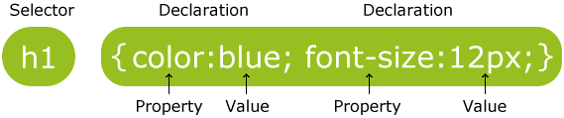

The selector is normally the HTML element you want to style.

Each declaration consists of a property and a value.

The property is the style attribute you want to change. Each property has a value.

CSS Example:

A CSS declaration always ends with a semicolon, and declaration groups are surrounded by curly brackets:

|  |
| --- |
| p {color:red;text-align:center;} |

## CSS Comments:

Comments are used to explain your code, and may help you when you edit the source code at a later date. Comments are ignored by browsers.

A CSS comment begins with "/*", and ends with "*/".

# CSS Id and Class:

|  |
| --- |
|  |

## The id and class Selectors

In addition to setting a style for a HTML element, CSS allows you to specify your own selectors called "id" and "class".

## The id Selector:

The id selector is used to specify a style for a single, unique element.

The id selector uses the id attribute of the HTML element, and is defined with a "#".

## The class Selector:

The class selector is used to specify a style for a group of elements. Unlike the id selector, the class selector is most often used on several elements.

This allows you to set a particular style for many HTML elements with the same class.

The class selector uses the HTML class attribute, and is defined with a "."

In the example below, all HTML elements with class="center" will be center-aligned:

|  |  |
| --- | --- |
| Example  |  | | --- | | .center {text-align:center;} | |

## Three Ways to Insert CSS

There are three ways of inserting a style sheet:

* External style sheet
* Internal style sheet
* Inline style
* External Style Sheet

An external style sheet is ideal when the style is applied to many pages. With an external style sheet, you can change the look of an entire Web site by changing one file. Each page must link to the style sheet using the <link> tag. The <link> tag goes inside the head section:

|  |
| --- |
| <head> <link rel="stylesheet" type="text/css" href="mystyle.css" /> </head> |

An external style sheet can be written in any text editor. The file should not contain any html tags. Your style sheet should be saved with a .css extension. An example of a style sheet file is shown below:

|  |
| --- |
| hr {color:sienna;} p {margin-left:20px;} body {background-image:url("images/back40.gif");} |

## Internal Style Sheet:

An internal style sheet should be used when a single document has a unique style. You define internal styles in the head section of an HTML page, by using the <style> tag, like this:

|  |
| --- |
| <head> <style type="text/css"> hr {color:sienna;} p {margin-left:20px;} body {background-image:url("images/back40.gif");} </style> </head> |

## Inline Styles:

An inline style loses many of the advantages of style sheets by mixing content with presentation. Use this method sparingly!

To use inline styles you use the style attribute in the relevant tag. The style attribute can contain any CSS property. The example shows how to change the color and the left margin of a paragraph:

|  |
| --- |
| <p style="color:sienna;margin-left:20px">This is a paragraph.</p> |

# CSS Background:

CSS background properties are used to define the background effects of an element.

CSS properties used for background effects:

* background-color
* background-image
* background-repeat
* background-position

## All CSS Background Properties:

|  |  |
| --- | --- |
| **Property** | **Description** |
| Background | Sets all the background properties in one declaration |
| background-attachment | Sets whether a background image is fixed or scrolls with the rest of the page |
| background-color | Sets the background color of an element |
| background-image | Sets the background image for an element |
| background-position | Sets the starting position of a background image |
| background-repeat | Sets how a background image will be repeated |

## All CSS Text Properties:

|  |  |
| --- | --- |
| **Property** | **Description** |
| Color | Sets the color of text |
| Direction | Specifies the text direction/writing direction |
| letter-spacing | Increases or decreases the space between characters in a text |
| line-height | Sets the line height |
| text-align | Specifies the horizontal alignment of text |
| text-decoration | Specifies the decoration added to text |
| text-indent | Specifies the indentation of the first line in a text-block |
| text-shadow | Specifies the shadow effect added to text |
| text-transform | Controls the capitalization of text |
| vertical-align | Sets the vertical alignment of an element |
| white-space | Specifies how white-space inside an element is handled |
| word-spacing | Increases or decreases the space between words in a text |

**11.Implementation**

Implementation is the stage of the project where the theoretical design is turned into a working system. It can be considered to be the most crucial stage in achieving a successful new system gaining the users confidence that the new system will work and will be effective and accurate. It is primarily concerned with user training and documentation. Conversion usually takes place about the same time the user is being trained or later. Implementation simply means convening a new system design into operation, which is the process of converting a new revised system design into an operational one.

Implementation includes all those activities that take place to convert from the existing system to the new system. The new system may be a totally new, replacing an existing manual or automated system or it may be a modification to an existing system. Proper implementation is essential to provide a reliable system to meet organization requirements. The process of putting the developed system in actual use is called system implementation. This includes all those activities that take place to convert from the old system to the new system. The system can be implemented only after through testing is done and if it is found to be working according to the specifications. The system personnel check the feasibility of the system. The more complex the system being implemented, the more involved will be the system analysis and design effort required to implement the three main aspects: education and training, system testing and changeover. The implementation state involves the following tasks:

* Careful planning.
* Investigation of system and constraints.
* Design of methods to achieve the changeover.
* Training of the staff in the changeover phase.

**12. SCREENSHOTS**

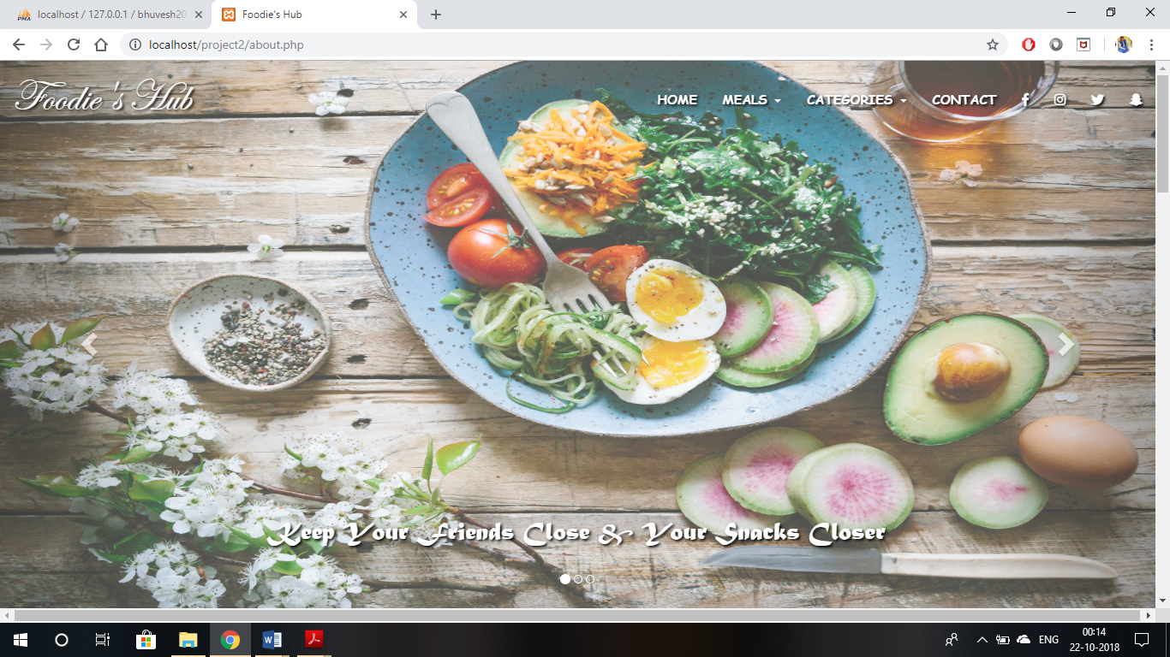

**FIGURE-12.1 HOME PAGE**

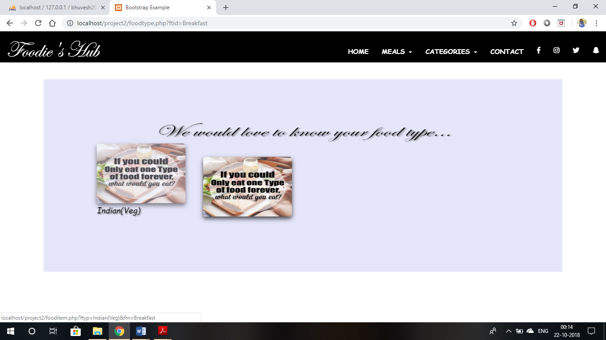

**FIGURE-12.2 FOOD TYPE PAGE**

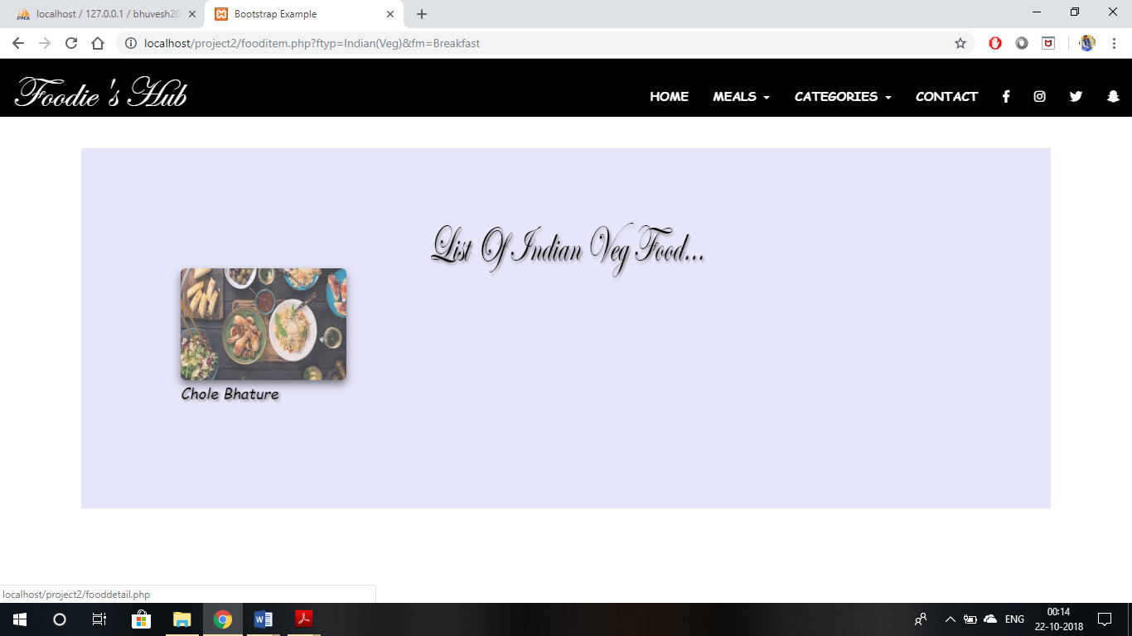

**FIGURE-12.3 FOOD ITEM PAGE**

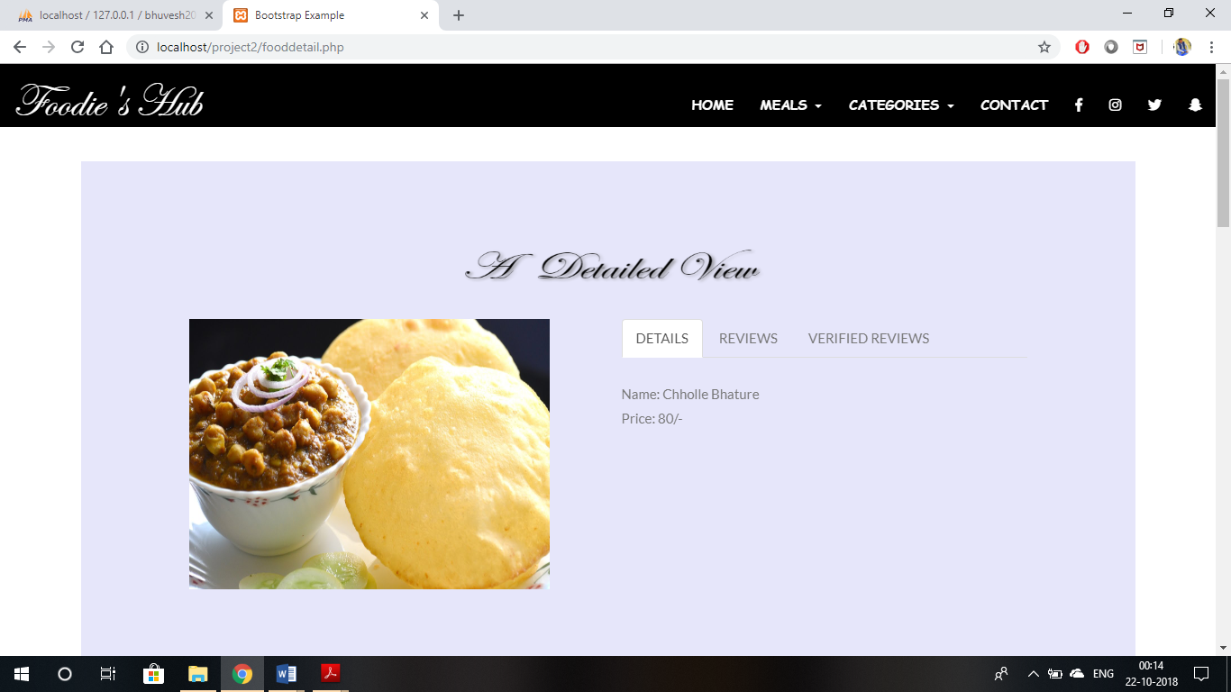

**FIGURE-12.4 FOOD ITEM DETAILS PAGE**

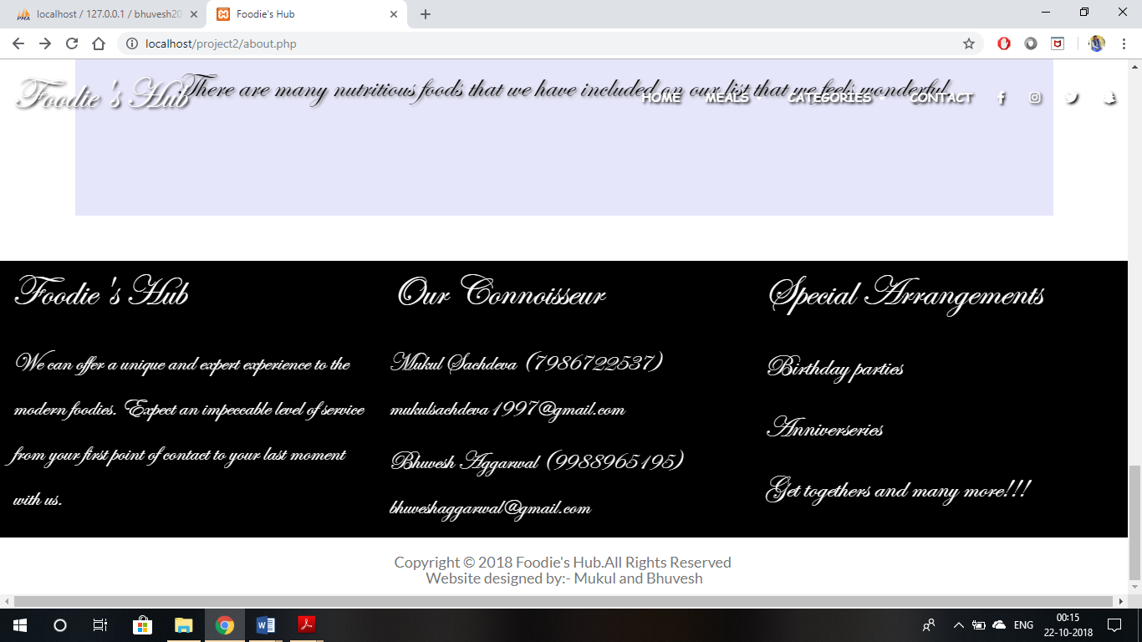

**FIGURE-12.5 CONTACT DETAILS**

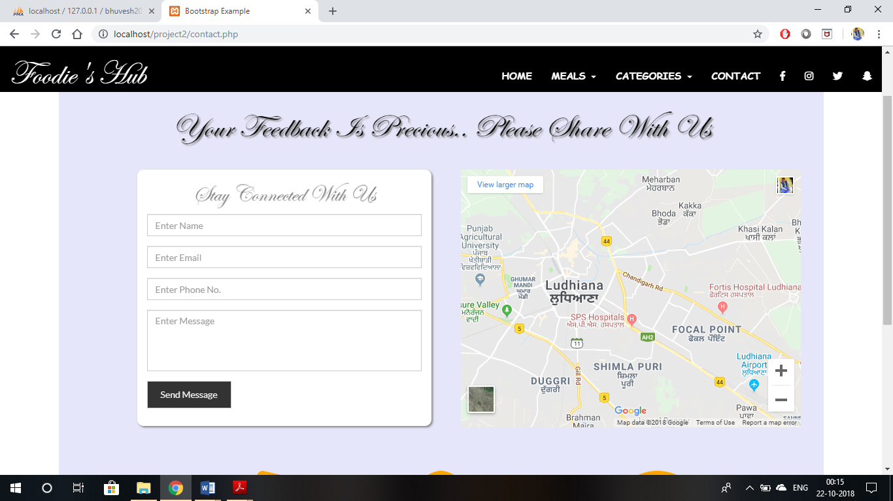

**FIGURE-12.6 FEEDBACK PAGE**

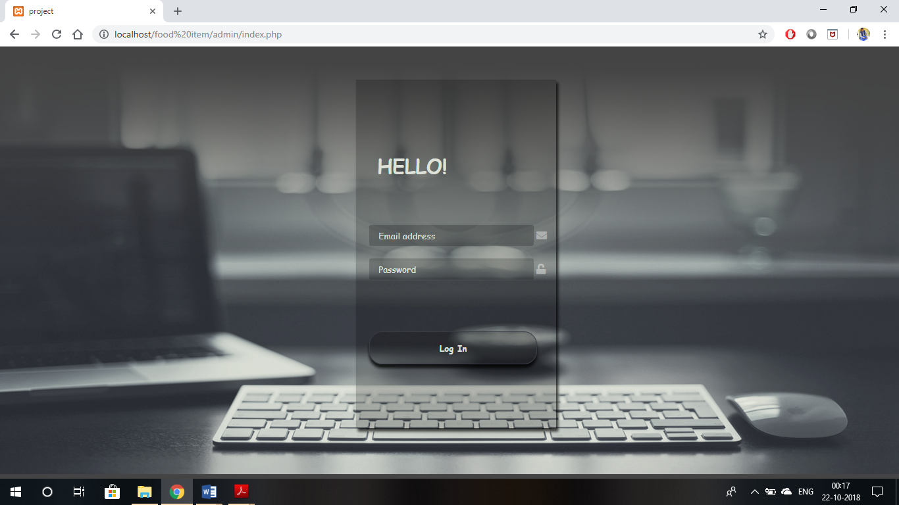

**FIGURE-12.7 Back End Admin Login Page**

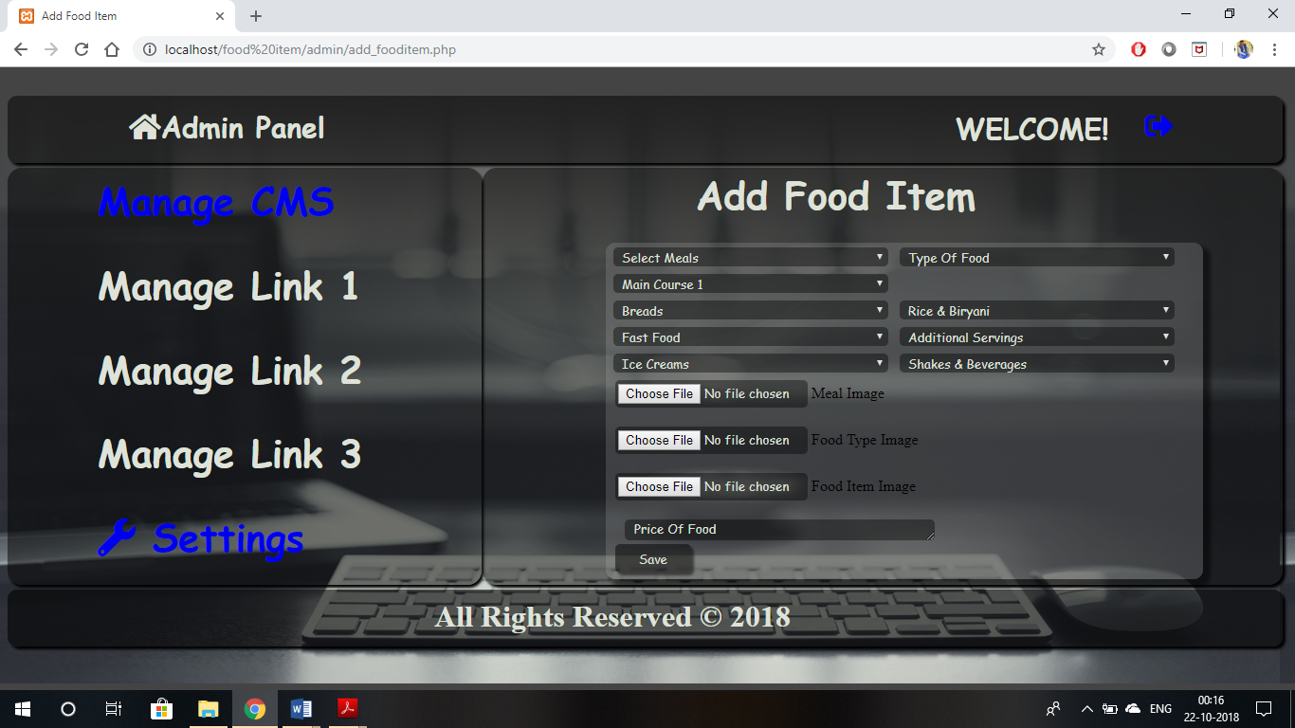

**FIGURE-12.8 Back End Add Food Item Page**

**13. Testing:**

Testing is the process of executing the programs with the intention of finding out errors. During the process, the program to be tested is executed with set of cases and the output of program and the test cases is evaluated to determine if the program is performing as expected. Testing makes a logical assumption that if all the parts of the module are correct the goals will be successfully achieved. Testing includes:

1. **Positive Testing**: Positive testing is making sure that new program do intact process. Certain transactions according to specifications.
2. **Negative Testing**: Negative testing is to test those transactions, which are not according to the specifications.

Testing of project, as we discussed above, is of two types – positive and negative.

The positive testing and negative testing both helps us to make our project more efficient. Our project has been tested from the customers, and we get both negative and positive responses. Real Estate is tested from the customers, some points that should be need to added in this project that we got from Customers, we add that additions in the project.

And the negative testing helps us to make the project clearly and very simple, so that every person can use it and visit the different properties, as we know this is a website in which we keep and maintain the record of our customers and the records of properties.

**13.1 Levels of testing**

Testing is an important step in software development life cycle. The process of testing takes place at various stages of development in programming. This is a vital step in development life cycle because the process of testing helps to identify the mistakes and sends the program for correction.

This process gets repeated at various stages until the final unit or program is found to be complete thus giving a total quality to the development process. The various levels and types of testing found in a software development life cycle are:

**13.1.1 White Box Testing**

For doing this testing process the person has to access to the source code of the product to be tested. So it is essential that the person doing this white box testing have some knowledge of the program being tested. Though not necessary it would be more worth if the programmer itself does this white box testing process since this testing process requires the handling of source code.

**13.1.2 Black Box Testing**

This is otherwise called as functional testing. In contrary to white box testing here the person who is doing the black box testing need not have the programming knowledge. This is because the person doing the black box testing would access the output or outcomes as the end user would access and would perform thorough functionality testing to check whether the developed module or product behaves in functionality in the way it has to be.

**13.1.3 Unit testing**

Try to detect if all application functions work correct individually.

**13.1.4 Integration testing**

Try to detect if all these functions are accessible in our application and they are properly integrated.

**13.1.5 System Testing**

System testing checks if the integrated product meets the specified requirements.

**13.1.6 Acceptance Testing**

Acceptance testing is the phase of testing used to determine whether a system satisfies the requirements specified in the requirements analysis phase. The acceptance test design is derived from the requirements document. The acceptance test phase is the phase used by the customer to determine whether to accept the system or not.

**14. Conclusion and Future Scope**

**14.1 Conclusion:**

The entire project has been developed and deployed as per the requirements stated by the user, it is found to be bug free as per the testing standards that is implemented. Any specification-untraced errors will be concentrated in the coming versions, which are planned to be developed in near future.

You can use this project at anywhere, when you need it, you can use it. In future you can take more features by updating new to new technology. There is simple interface, you can easily use and understand this that how you can use it.

It provides you secure authority so that your data should be secured in future, so that your data is not misused, you never lose your customer data as in windows system. It will provide you more feature as the technology advancements.

**14.2 Future scope**

The scope of any project defines how it can be used in future and what functions we can perform using that project. Scope of any project will also clarify the idea of that what a project is of about. Thus it is the scope of a project which determines the only goal for that project.

The basis for development of any new system is recognition or identification of a need for improving an information system or procedure.

This project which is a Web Portal will give an overview how a website related to the property business will work and what we can find related to our interest on a website like this.

In future we can able to add more modules in this project. In the proposed system the user is provided with a choice of data screen, which are similar in formats to the source documents. Data entry errors can be minimized through validity checks. After the verification only the data are placed in the permanent database. The software can be developed further to include a lot of modules because the proposed system is developed on the view of future, for example we should develop the system as a database independent using database so we can connect it to any other database. Now the proposed system is based on PC and intranet but in the future if we need to convert it into internet then we need to change the front end only because we are developing this on the basis of PHP technology.

**15. APPENDIX**

**15.1 Module Description**

Modules of the projects are describe here:-

* List of Modules :

1. Customers
2. Entry
3. Balance
4. Reminder
5. My Day Book
6. Help

**15.2 How to use the project..?**

* **Homepage:-**

The Homepage is the main screen area that you see after you Start Daybook application on to mobile. It contains list of Contact us, Store location, About us, etc. which are use for multiple purposes. User can easily understand the uses of buttons with the help of images which are provided on buttons. There are different links on the Home page

* **About Us**
* **Contact Us**
* **Log In**

**16.Refrences**

* <http://www.w3schools.com/>
* <http://www.tutorialspoint.com/bootstrap>
* <http://en.wikipedia.org/wiki/Cascading_Style_Sheets>
* <http://stackoverflow.com/>
* [www.Fontawesome.com](http://www.fontawesome.com/)
* [www.php.com](http://www.php.com/)
* [www.wikipedia.org](http://www.wikipedia.org/)
* [www.animate.css](http://www.animate.css/)